Alexander Baldree
3/24/26
Module 1 Assignment 1.2
CSD420

Git Hub Link:
https://github.com/Panda-Alex21687/CSD420
Image of GitHub Repo:
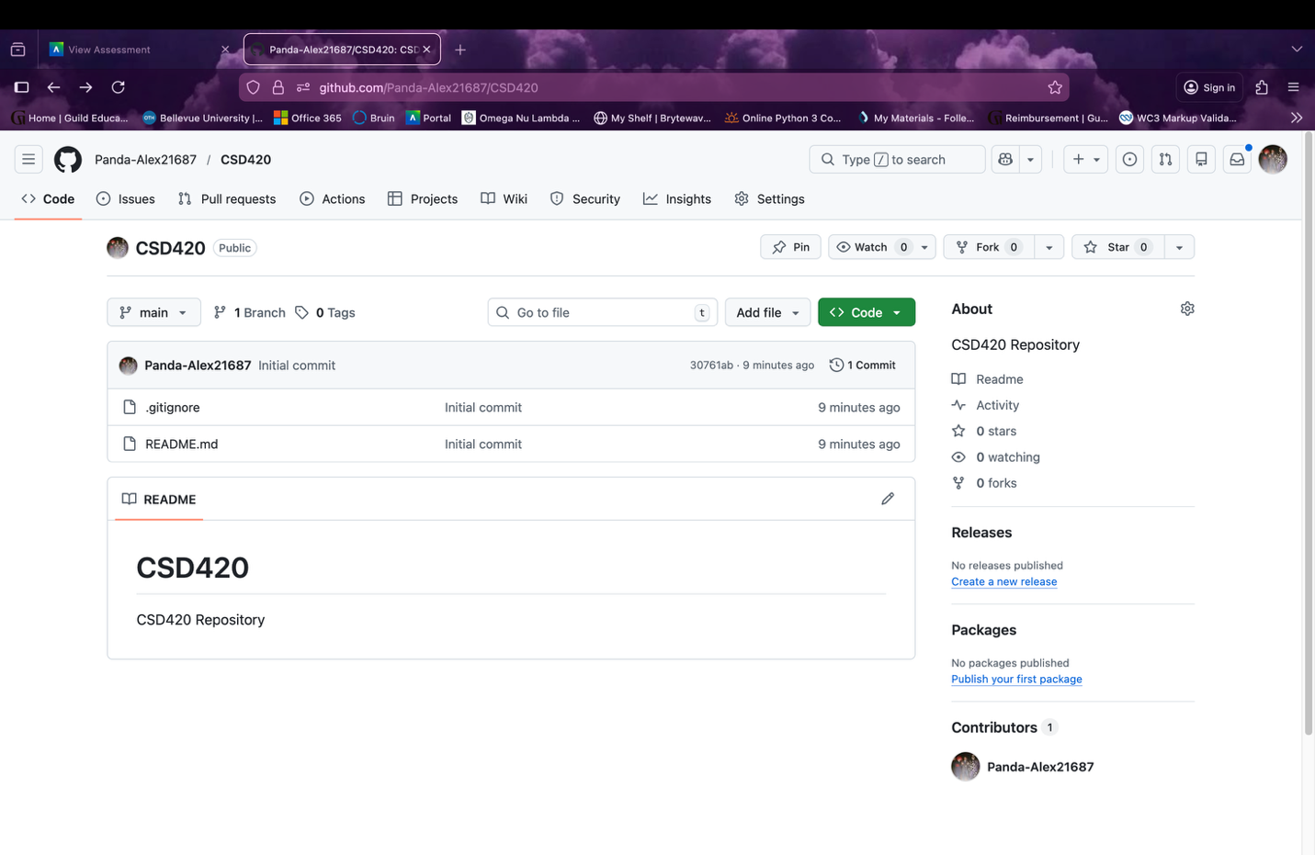
GitHub Repo in Terminal:
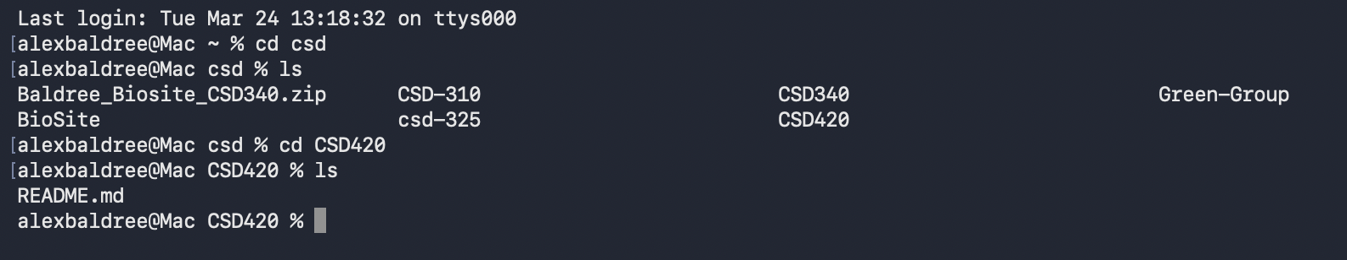
Folder in my Mac Files CSD:
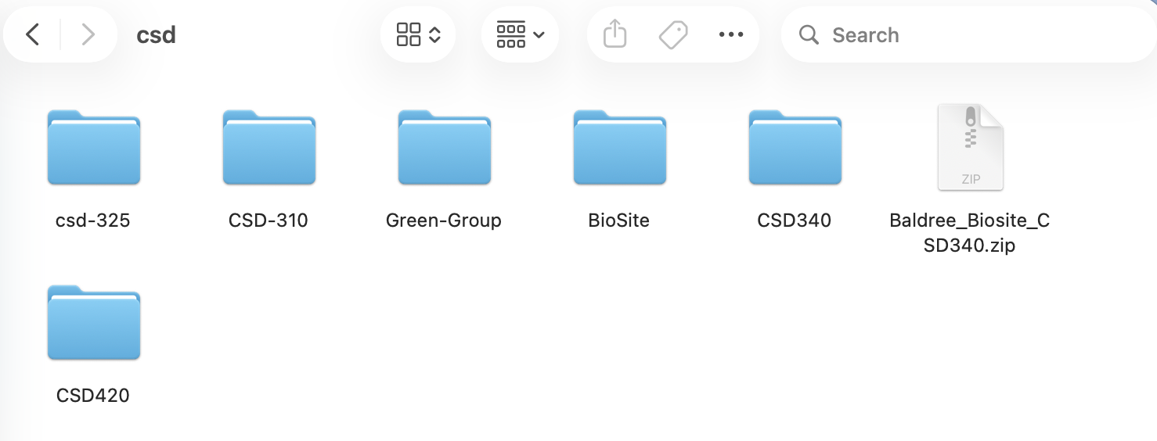
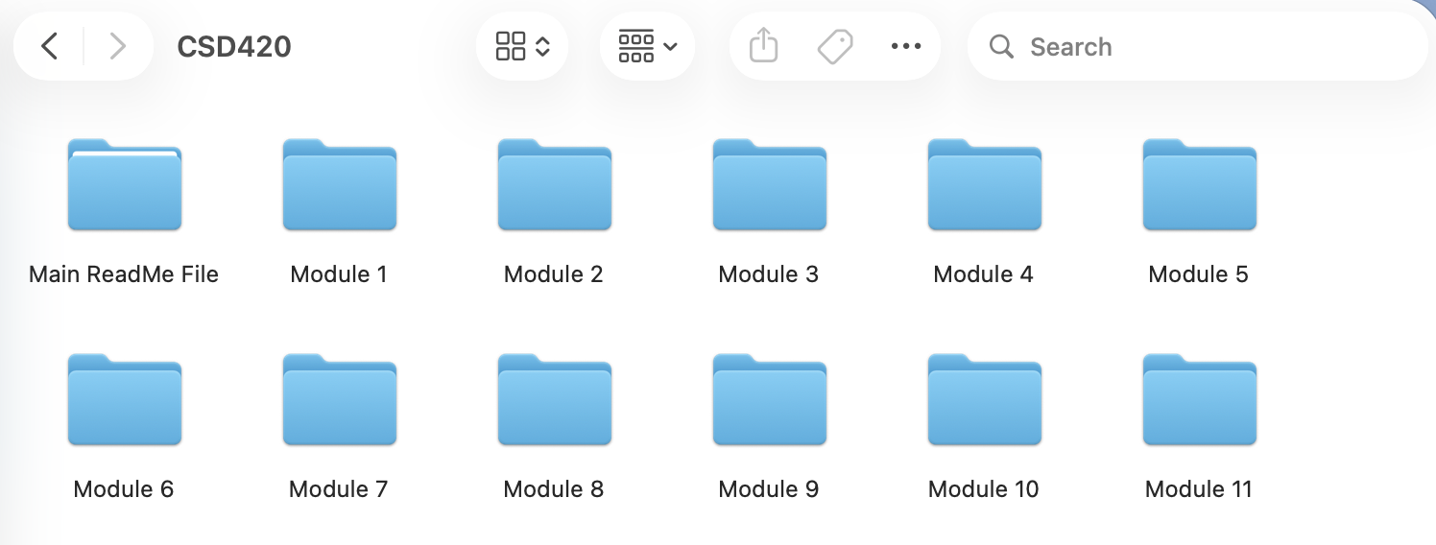
I organize all my files per Assignment / Module

My .gitignore is python as requested in the instructions:
